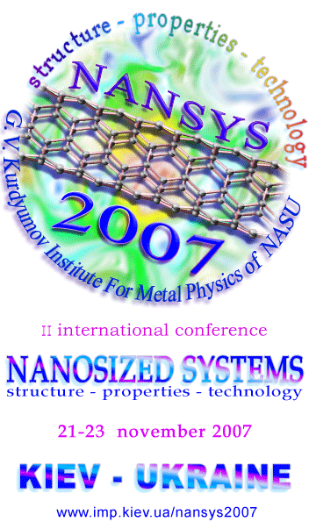

CONFERENCE CHAIRMEN
Shpak А.P. | IMP NAS of Ukraine, Kiev
Brodin М.S. | IP NAS of Ukraine, Kiev
Volkov S.V. | IGNC NAS of Ukraine, Kiev
Kuchuk-Yatsenko S.I. | EWI NAS of Ukraine, Kiev
Naumovets А.G. | IP NAS of Ukraine, Kiev
Nakhodkin N.G. | Shevchenko National University, Kiev
Neklyudov I.М. | KIPT NAS of Ukraine, Kharkov
Pokhodenko V.D. | IPC NAS of Ukraine, Kiev
Skorokhod V.V. | IPMS NAS of Ukraine, Kiev
Machulin V.F. | IPS NAS of Ukraine, Kiev
Varyukhin V.N. | DIPE NAS of Ukraine, Donetsk
Gorbik P.P. | ICS NAS of Ukraine, Kiev
Ulberg Z.R. | IBCC NAS of Ukraine, Kiev

CONFERENCE ORGANIZING COMMITTEE
Chairman
Shpak А.P. | IMP NAS of Ukraine, Kiev
Vice-chairman
Uvarov V.N. | IMP NAS of Ukraine, Kiev
Secretary
Rud А.D. | IMP NAS of Ukraine, Kiev
Organizing committee members
Antonov V.N. | IMP NAS of Ukraine, Kiev
Blonskiy І.V. | IP NAS of Ukraine, Kiev
Ischenko А.Ya. | EWI NAS of Ukraine, Kiev
Kuchmiy S.Ya. | IPC NAS of Ukraine, Kiev
Ostafiychuk B.K. | PNU of Ukraine,  Ivano-Frankivsk
Pekhnyo V.I. | IGNC NAS of Ukraine, Kiev
Solonin Yu.M. | IPMS NAS of Ukraine, Kiev
Stasyuk I.V. | IPSS NAS of Ukraine, г. Lviv
Karbovskiy V.L. | IMP NAS of Ukraine, Kiev
Konstantinova T.E. | DIPE NAS of Ukraine, Donetsk
Kynitskiy Yu.А. | TC NAS of Ukraine, Kiev
Nadutov V.M. | IMP NAS of Ukraine, Kiev
Prokopenko I.V. | IPS NAS of Ukraine, Kiev
Ragulya A.V. | IPMS NAS of Ukraine, Kiev
Freik D.M. | PCI of PSU of MES of Ukraine,  Ivano-Frankivsk
Shulaev V.М. | KIPT NAS of Ukraine, Kharkov
The conference is initiated and supported by National Academy of Science of Ukraine for the purpose of coordination of the research, the exchange of information about newest advances in the area of the research, production and application of nanodimensional systems and nanomaterials. The conference affords an opportunity to discuss new results and envelops major aspects of given problem: fundamental, applied and technological.

SESSION TOPICS
The reports on given topics will be considered at the conference:

[1] size-effects and self-organization of nanostructures and nanosystems;

[2] structure and properties of low-dimensional systems;

[3] metal- and carbon-based nanomaterials;

[4] semi-conducting nanosystems and nanostructures;

[5] films, coatings and surface nanosystems;

[6] biofunctional nanomaterials, nanosystems in biology and medicine;

[7] supramolecular structures, aerogels, colloid systems;

[8] diagnostics and modelling of nanostructures and nanoimensional systems;

[9] technologies of nanomaterials fabrication;

[10] practical use of nanomaterials.
LANGUAGES
Working languages of the conference are ukrainian, russian and english (for letters, abstracts, reports, articles).

PRESENTATION
Leading scientists having been invited will give the lectures at the conference. After reviewing submitted materials will be selected for oral and poster presentation.

PUBLICATION
Report's texts will be published in :
”Metal Physics and Newest Technologies”
”Advances of Metal Physics”
and theses book
”Nanosystems, Nanomaterials, Nanotechnology”

PRELIMINARY REGISTARATION
Persons who wish to take part at the conference should fill the preliminary registration form at the conference site:
www.imp.kiev.ua/nansys2007

or send it by Email:
E-mail: nansys2007@imp.kiev.ua

or conventional mail:
NANSYS - 2007
G.V. Kurdyumov Institute for Metal Physics
NAS of Ukraine
36, Vernadsky av.
03142 Kyiv
Ukraine

CONFERENCE PLACE
The conference will be carried out in the Kurdyumov Institute for Metal Physics, NAS of Ukraine.
HOST PLACES AND CULTURAL EVENTS
Conference participants will be accommodated at "Academicheskaya" hotel and other hotels in Kyiv. For this corresponding field should be filled in the registration form. Cultural program for participants and accompanying persons will be also provided.
REGISTRATION FEE
For participants – 100 UAH (equivalent for 20$), payment should be made during registration on-site.
Those who wish participate in the excursion in Kiyv should pay additional 50 UAH and fill the corresponding field in the registration form.
IMPORTANT DATES
Registration | till July 15, 2007
Second announcement | after July 15, 2007
Theses reception | till October 1, 2007
Paper acceptance notification | November 1, 2007
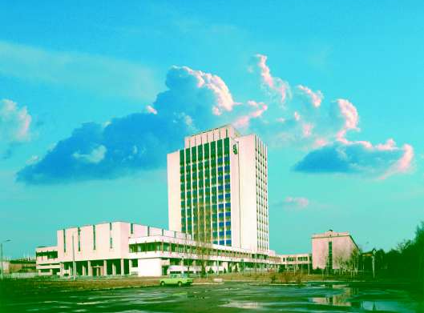

Fill with typewritten or printed letters
❑ | I intend to participate in the conference
❑ | I intend to represent a report
❑ | I intend to take part in excursion in Kyiv
❑ | I need ____ places in hotel to be reserved for period from ___11.2007 to ___11.2007
Suggested report title:
Topic number:
Male |  | Female
❑ |  | ❑
Last Name
First Name
Middle Name
Scientific degree
Academic status
Organization
Street
ZIP code
City/town
Country
Phone
Fax
E-mail

Contacts: nansys2007@imp.kiev.ua
Alexander Rud: +38-044-424-3210

