G.V. Kurdyumov Institute for Metal Physics of the N.A.S. Of Ukraine
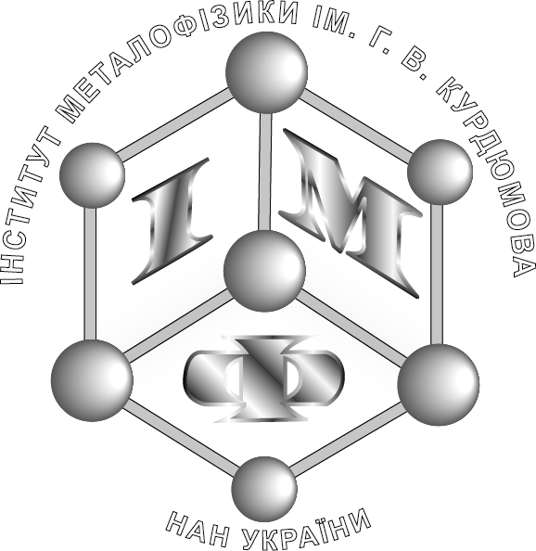  Working languages: Ukrainian, Russian, English | Welcome to the Conference  `up-to-date Problems Of the Physics of Metals And Metallic Systems`  Within the framework of the Research and Training Session devoted to the 70th-Anniversary of Institute  The conference will be held on 25−27 May 2016  Address: 36 Academician Vernadsky Blvd, Kyiv  (G.V. Kurdyumov Institute for Metal Physics of the N.A.S. of Ukraine)
TOPICS
- Physics of strength and plasticity of metals and alloys
- Atomic constitution of metals and metal-containing heterophase structures
- Electronic structure and properties of metals and metal-based compounds
- Nanoscale and nanostructured systems
Programme Committee
O.M. Ivasishin, Member of the N.A.S.U. – chairman  (G.V. Kurdyumov Institute for Metal Physics of the N.A.S.U.) | D.G. Savvakin, Dr. Sci. (Phys.-Math.), Sr. Res. Sci. – secretary  (G.V. Kurdyumov Institute for Metal Physics of the N.A.S.U.)
O.S. Bakai, Member of the N.A.S.U.  (National Science Centre `Kharkiv Institute for Physics and Technology` of the N.A.S.U.)  V.G. Bar’yakhtar, Member of the N.A.S.U.  (Institute of Magnetism of the N.A.S.U. and the M.E.S.U.)  V.M.Loktev, Member of the N.A.S.U.  (M. M. Bogolyubov Institite for Theoretical Physics of the N.A.S.U.)  A.G. Naumovets, Member of the N.A.S.U.  (Institute of Physics of the N.A.S.U.)  S.O. Firstov, Member of the N.A.S.U.  (I.M. Frantsevich Institute for Problems in Materials Science of the N.A.S.U.)  V.M. Varjukhin, Corresponding member of the N.A.S.U.  (Donetsk Institute for Physics and Engineering named after O. O. Galkin of the N.A.S.U.)  V.B. Molodkin, Corresponding member of the N.A.S.U.  (G.V. Kurdyumov Institute for Metal Physics of the N.A.S.U.)  A.M. Pogorilyi, Corresponding member of the N.A.S.U.  (Institute of Magnetism of the N.A.S.U. and the M.E.S.U.)  V.M. Uvarov, Corresponding member of the N.A.S.U.  (G.V. Kurdyumov Institute for Metal Physics of the N.A.S.U.) | P.P. Gorbyk, Dr. Sci. (Phys.-Math.), Prof.  (O.O. Chuiko Institute of Surface Chemistry of the N.A.S.U.)  Ye.M. Kyslovskyi, Dr. Sci. (Phys.-Math.), Prof.  (G.V. Kurdyumov Institute for Metal Physics of the N.A.S.U.)  V.M. Nadutov, Dr. Sci. (Phys.-Math.), Prof.  (G.V. Kurdyumov Institute for Metal Physics of the N.A.S.U.)  V.M. Poroshyn, Dr. Sci. (Phys.-Math.), Sr. Res. Sci.  (Institute of Physics of the N.A.S.U.)  E.M. Rudenko, Dr. Sci. (Phys.-Math.), Prof.  (G.V. Kurdyumov Institute for Metal Physics of the N.A.S.U.)  V.A. Tatarenko, Dr. Sci. (Phys.-Math.), Prof.  (G.V. Kurdyumov Institute for Metal Physics of the N.A.S.U.)  A.I. Ustinov, Dr. Sci. (Phys.-Math.), Prof.  (E.O. Paton Electric Welding Institute of the N.A.S.U.)  V.Ye. Shaternik, Dr. Sci. (Phys.-Math.), Sr. Res. Sci.  (G.V. Kurdyumov Institute for Metal Physics of the N.A.S.U.)

Local Committee (G.V. Kurdyumov Institute for Metal Physics of the N.A.S. of Ukraine)
V.A. Tatarenko, Dr. Sci. (Phys.-Math.), Prof. – chairman | T.P. Vladimirova, Cand. Sci. (Phys.-Math.) | S.V. Lizunova, Cand. Sci. (Phys.-Math.)
V.S. Filatova, Cand. Sci. (Phys.-Math.) – secretary | Ie. V. Kochelab, Cand. Sci. (Phys.-Math.) | K.G.Levchuk, Cand. Sci. (Techn.)
V.P. Bevz, Cand. Sci. (Phys.-Math.) | V.V. Lizunov, Cand. Sci. (Phys.-Math.) | M.I. Katashynska

IMPORTANT DATES
Before 15.03.2016, submission of applications for participation together with a short abstract (up to ½ of a page) (download the sample at the Institute`s website)
Before 30.03.2016, notification about including the presentation to the conference programme and its format
INFORMATIONAL RESOURCES
You can find all information about the conditions of the conference holding and participation
at the official website of the Institute: http://www.imp.kiev.ua/
Phone for information:
38 (044) 422 95 89 (V.S. Filatova, secretary of the Local Committee)
38 (044) 424 31 10 (Ie. V. Kochelab, academic secretary of the G.V. Kurdyumov Institute for Metal Physics of the N.A.S.U.)
E-mail: mpmms@imp.kiev.ua

